Directions to Aid Stations at Twin Lakes Park
Aid Station at 2 mile mark:
From Twin Lakes park, drive east on 70th Ave, following it in a northeasterly direction until you get to the NAPA auto parts store. Park in the NAPA lot and walk south across 70th avenue. Look for the hole in the fence near the bus stop. Go through the hole in the fence to the path and the aid station.
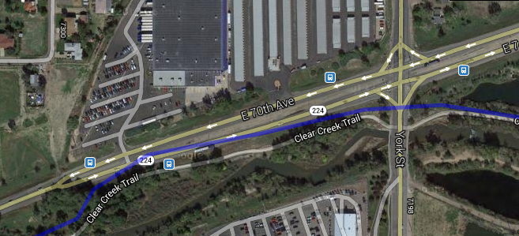
Aid station at ~3.8 miles.
Follow the directions above. Drive east on 70th Avenue past the NAPA store to York Street. Drive north (left) on York to E. 78Th Avenue. Turn East (right) on E 78th and follow it until it makes a left hand turn and changes names to Steele Street. About 100 yards after the turn, you’ll see a parking lot on the east side of Steele Street. Park in the lot. The aid station is on the Colorado Front Range Trail path off the southeast corner of the parking lot.